Daniel Schwartz  
Social Network Analysis 10-06-2022

Assignment 4

1. DC | DCNorm
   1. 2 1/3
   2. 2 1/3
   3. 2 1/3
   4. 3 1
   5. 2 1/3
   6. 1 1/6
2. BC | BCNorm

B: 7 7/10

E 4 | 2/5



D: 3

A: 4

1. C: 9
2. 1. 4 most central: A01 (16), A03 (10), A33 (12), A34 (17)
   2. 2 least central: A12 (1), A10 (2), although there are many that only have a centrality score of 2

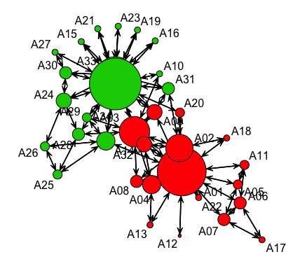

1. The orders for betweenness and degree are very similar. The differences start to become more frequent when you near the tail end of the ordered scores. For example, the 3rd to the 14th place in the order are exactly the same for both between and degree. Apart from these, the differences are very small, with most differences only being a difference of about 2 places.

1. When looking at the graph below, it appears that the vertices in the outer ring of around the big green circles are more important because they are about the same absolute size as the other graph, but much larger relative to the large circles in the center. The same can be said about the vertices surrounding the large center red circles.

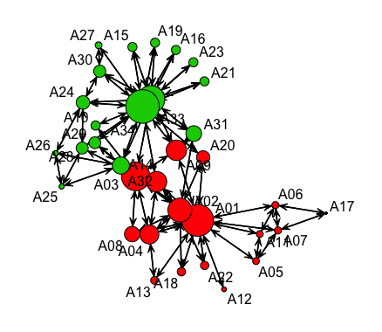



Degree Closeness Betweenness Eigenvector

Degree 1.000 -0.708 0.915 0.917

Closeness -0.708 1.000 -0.634 -0.865

Betweenness 0.915 -0.634 1.000 0.803

Eigenvector 0.917 -0.865 0.803 1.000

The pairs of scores that are most closely associated are:

1. Degree –– Eigenvector
2. Degree –– Betweenness
3. Betweenness –– Eigenvector

The pairs that are least closely linked are:

1. Closeness –– Eigenvector
2. Closeness –– Degree
3. Closeness –– Betweenness

Not normalized | Normalized

Degree 844 0.400

Betweenness 14132.86 0.406

The inequality among club members is greatest for Betweenness centrality, because unnormalized and normalized numbers are both higher than that of Degree centrality, there is a higher amount of centralization for a few nodes.